Generate Motion Profile Trajectory using VSC

FRC Team 3654

1/27/2021

This document describes how to use Visual Studio Code to generate the motion profile trajectory file using Jaci’s Pathfinder v1 library. It assumes the user has experience in WPILib version of Visual Studio Code. The motion profile trajectory file is needed to control the robot to move at the specified path defined in the trajectory file.

1. **Create One Folder**

The second folder is: **C:\Pathfinder\autonomous** which is used to contain the Pathfinder library and the generated motion profile trajectory files.

1. **Install Visual Studio Code**

The WPI Version of VSC is not included here.

1. **Get data from Github**

For year 2021, the project is in <https://github.com/FRCTeam3654/2021prod_robot/>. Get the latest version. Under the folder: documentations/Pathfinder_MotionProfile/pathfinder3654VSC, it has the Java project code using Pathfinder v1 to generate the motion profile path. [TankArc.java](https://github.com/FRCTeam3654/2021prod_robot/blob/master/documentations/Pathfinder_MotionProfile/pathfinder3654VSC/src/TankArc.java" \o "TankArc.java) under src folder is the program to generate the path and save data file to the **C:\Pathfinder\autonomous** folder**.**

You may copy pathfinder3654VSC folder to another place for playing the code.

1. **Open folder** pathfinder3654VSC,

Open folder pathfinder3654VSC in VSC, open TankArv.java file

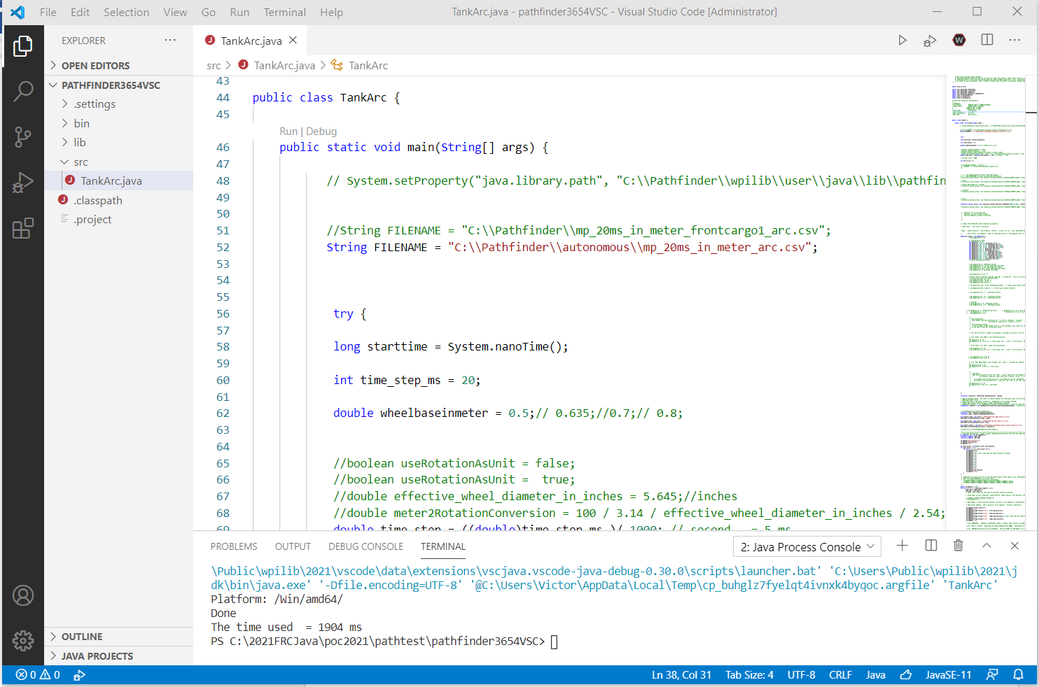

You can study the source code and modify some of the value for your need.

Some changes :

String FILENAME = "C:\\Pathfinder\\autonomous\\mp_20ms_in_meter_arc.csv";

double wheelbaseinmeter = 0.5;// 0.635;//0.7;// 0.8;

Trajectory.Config config = new Trajectory.Config(Trajectory.FitMethod.HERMITE_CUBIC, Trajectory.Config.SAMPLES_HIGH, time_step, 1.7, 2.0, 60.0);

Waypoint[] points = new Waypoint[] {

The most important is the set of Waypoint that defines the path.

Once you have changed the parameter to your need, you can generate the profile file now.

1. **Generate Motion Profile Trajectory File**

Right click on anywhere in the main panel of TankArc.java, select “Run”.

You can verify the generated files by opening Window’s Explorer and checking the files in folder “C:\Pathfinder\ autonomous”. It should have two files:

mp_20ms_in_meter_arc.csv

mp_x_y_center_test_arc.csv

1. **Plot the Path**

This step is **optional,** but it is fun to see how your robot is supposed to move visually.

Under folder documentations\Pathfinder_MotionProfile\VisualizeByHTML,

Open chartjs_xy_x_y_scatter.html in Chrome browser ( it won’t work in Explorer or Edge).

In browser, at the bottom, click on “Choose File”, and go to C:\Pathfinder\ autonomous and select mp_x_y_center_test_arc.csv. This will display the robot’s track in (x,y) position.

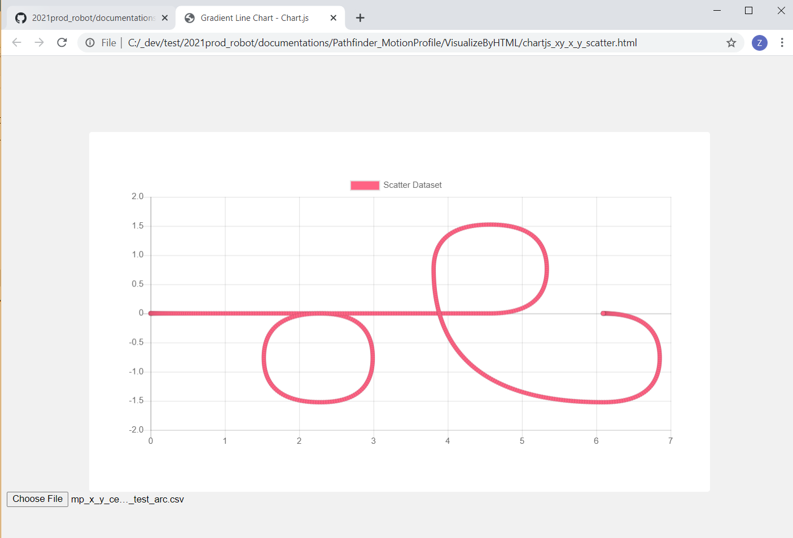

1. **Upload the Trajectory File into RoboRIO**

Depending on the file name specific in autonomous code, you may need rename mp_20ms_in_meter_arc.csv to a file name the program is expecting such as mp_20ms_in_meter_arc_1_1.csv

You will need WinSCP to upload the trajectory file “mp_20ms_in_meter_arc_1_1.csv” into RoboRIO’s. You can download the WinSCP from <https://winscp.net/eng/download.php> if you have not installed it.

The robot need be turned on, and is connected to PC via Ethernet cable. You can use USB cable too but you need modify the RoboRIO host name to 172.22.11.2 instead of roborio-3654-frc.local.

Open WinSCP, use “roborio-3654-frc.local” as Host name, “SCP” as File protocol, and “22” as Port number. User name is “admin”, nothing in Password.

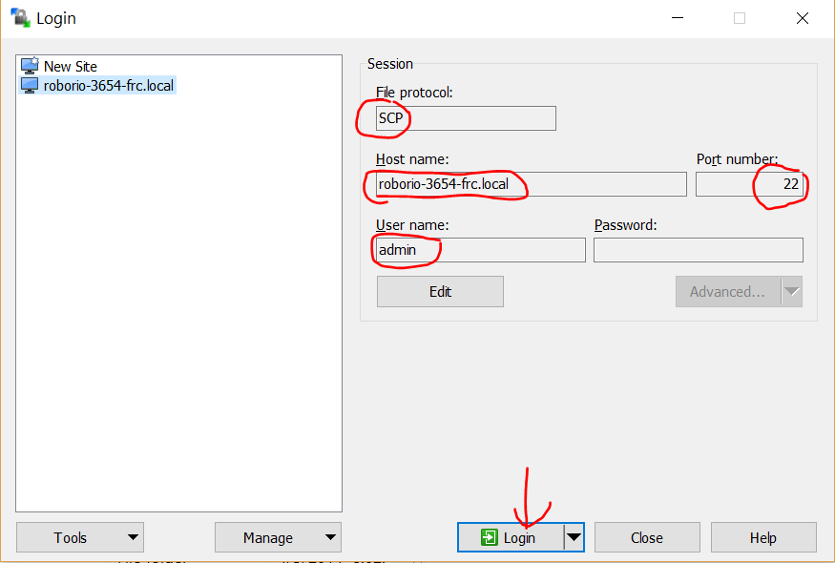

Click “Login” button. After login, at RoboRIO side, got to /home/lvuser folder if you are not at this folder.

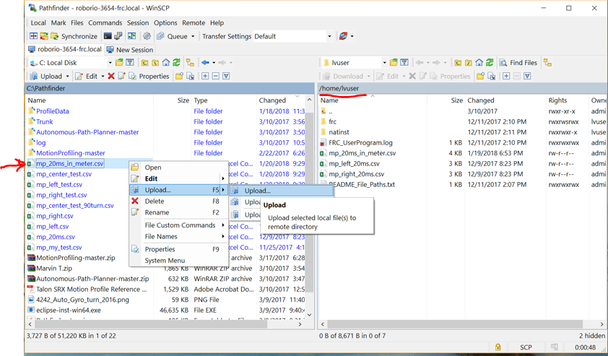

You can select the file in your pc you want to upload and upload it to /home/lvuser in RoboRIO.

Once the trajectory file is in RoboRIO, you are ready to use LabView to read the file to control the robot.